Saduq Rahman

February 21, 2021

Foundations of Programming, Python

Assignment 6

**CDIventory Python Using Functions**

**Introduction**

In assignment 6 we begin to utilize functions which is a group of related statements that performs a specific task. Functions tend to help break-up our program into smaller and modular chunks as your program grows larger and larger, functions make it more organized and manageable. Especially if you going to have multiple, individuals working on the same project. Once the function has been defined using the “def” which marks the start of the function. To call the function we simply type the function name with appropriate parameters that we want to pass to it. Which is used to utilize the code in more than one place in a program making the code reusable.

**Drafting the Code**.

I used the program spyder to write and test the code being written, my first step was going thru the labs by the teacher in module 6. To try and grasp the concept utilizing functions in addition I spent allot of time watching the YouTube videos (<https://youtu.be/_ypAw_pCOt8>). Also, had to read the chapter 6 of (Dawson, 2010) a few times to really get the concept to sink in. When constructing the code that was given to us one of the issues I had was getting to I/O get_input function to take user input and append it to the lsTble, my first thought was to nest the modules in order to make it work, but after discussing the issue with the teacher assistant and pointing me in the right direction I begin to understand that I needed to use the parameters in order pass the argument to the function and also let the module know that it should expect a return value back to pass on.

As you’ll see within the figures depicted below:

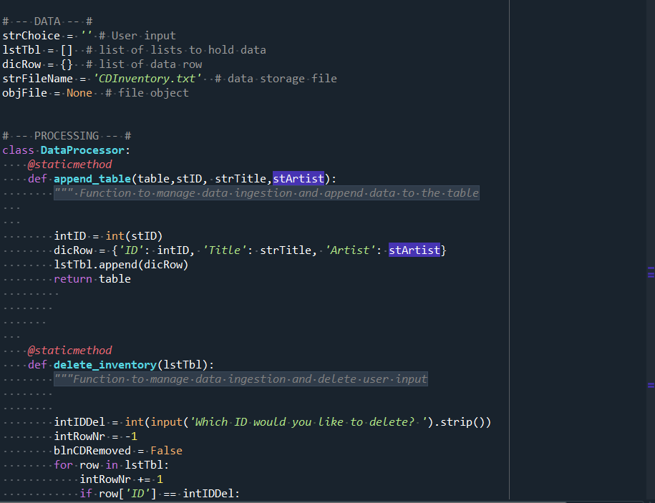

Figure I

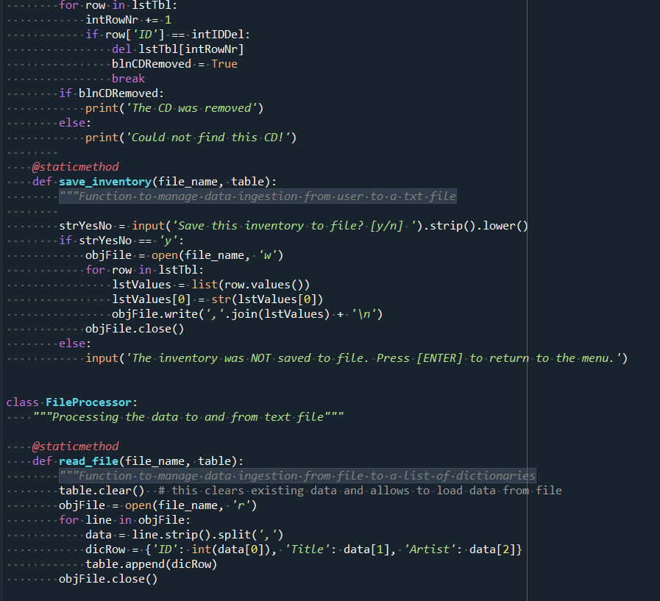

Figure II

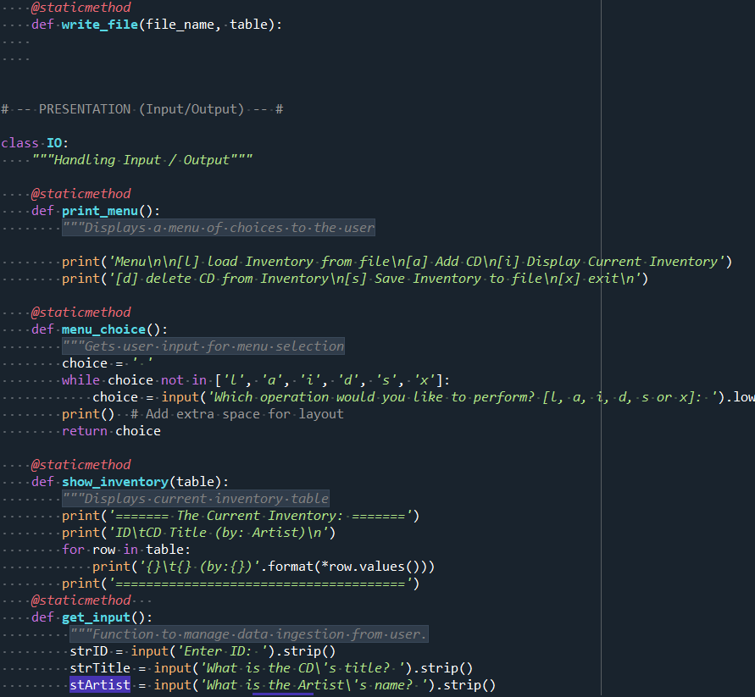

Figure III

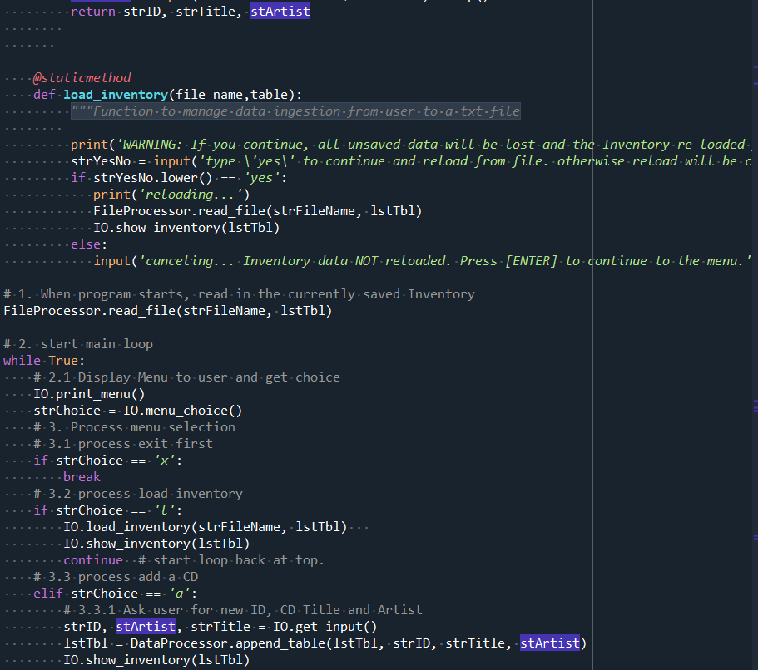

Figure IIII

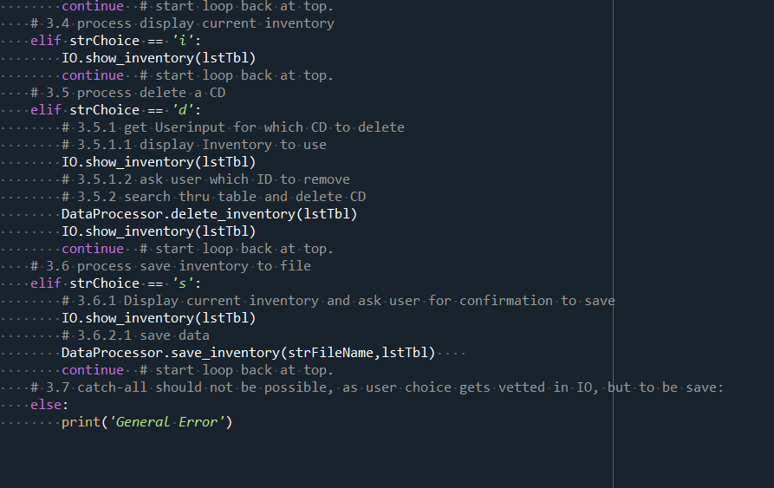

Figure V

**Operations:**

The output in the program displays the current inventory for the user within the program.

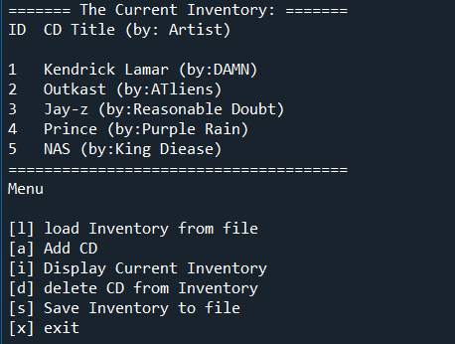

Figure V

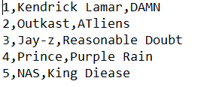

Figure IV

**Summary**

Using the textbook, the Module 06 documentation and videos, and the supplemental websites and video, I was able to successfully create a script that took the users input and wrote it to .txt file. Looking forward to improving on the concepts I have learned so far.